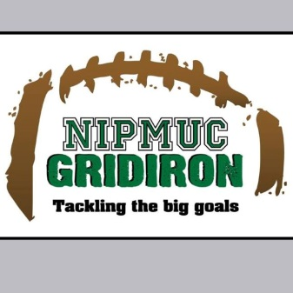

**2018 NIPMUC GRIDIRON CLUB**

**MEMBERSHIP FORM**

**\*BREAKING NEWS*....DID YOU KNOW YOUR MEMBERSHIP DUES GETS YOU FREE ADMISSION TO EVERY REGULAR SEASON HOME GAME, INCLUDING OUR FIRST EVER FRIDAY NITE LIGHTS HOME GAME ON OCTOBER 5TH!**

WE NEED YOU!! The Nipmuc Gridiron Club funds a variety of athletic needs for our football and cheer program. We fund items that are not covered by the school budget or athletic fees. We volunteer our services to help the administration with many game day endeavors such as chain gang, concessions, merchandising, scoreboard operators and many other tasks as needed. Our primary objective is to stimulate and support our student athletes in order to create a positive and spirited team environment. We are a group of positive, spirited, motivated people and we need your help!

**2017 Gridiron Contributions Included:**

**\*Championship jackets for every football player**

**\*$1,500 Cheer Choreography contribution**

**\*Green and White practice jerseys for Varsity and JV Squads.**

**\*Semi-Final Game Coach Buses for Cheer and Football Players!**

**\*Many pre/post game meals**

**\*Game Day concessions, chain gang, film, and merchandise by our awesome volunteers.**

**\*Banquet (free admission for all athletes).**

**2018.....MANY more exciting things to come......Become part of the Gridiron Club today!**

Please complete the membership form below and hand in to any Board member, or mail and make checks payable to the Nipmuc Gridiron Club, 90 Pleasant Street, Upton, MA 01568.

----------------------------------------------------

**NAME(s)________________________________________**

**EMAIL:________________________________**

**PHONE:________________________**

**$30 Individual* Member Donation:______**

**$50 Family* Member Donation:_______**

**(*includes free admissions tickets to regular season home games for the individual or the family)**

**Please show your support by volunteering for: (circle all that apply!)**

**Concessions Merchandise Table Sponsorship committee Pasta Dinners Fundraising Media Relations**

**50/50 Raffle Sales Game Filming Home Game Photos**

**Game Spotter Game Stats**

**We welcome your support, spirit and ideas! Please join us today and help make it a successful and fun season for Nipmuc Football and Cheer!!**

**The Gridiron Club meets the second Tuesday of every month at 7pm in the PDC room at Nipmuc!**